**Predicting Severe Coral Reef Bleaching Based on Global Anthropogenic Activity**

Oceanography Proposal

Alessandro Barlotta, Don Bonifacio, Logan Bukowski, Sophia Capili, and Kiernan Geoghegan

**Abstract**

Coral reefs, crucial ecosystems that collectively support 25% of the ocean’s fish, suffer coral bleaching or “whitening.” Anthropogenic pollutants like agricultural pesticides from rivers, wastewater discharged into the sea, and sunscreen and personal care products (e.g. benzophenone, octyl methoxycinnamate) that accumulate in high-human activity areas and disrupt organisms’s reproduction and growth cycles.Such heavy human activity in the water and in the regions around coral reefs has had a disastrous effect on many reefs around the world. Other human activities also have had a very serious effect on the wellbeing on reefs including but not limited to poorly planned coastal development and off shore fishing. If human activity, particularly tourism, and coral reef bleaching are mapped, then areas of high human activity would result in critical coral reef damage. This study will heavily use machine learning algorithms to predict whether a country will have severe bleaching based on tourism. Action can be taken from the predictions (1) to pinpoint what places need to mitigate their anthropogenic impact and (2) illustrate the alarming spread of coral reef damage. Given parameters of anthropogenic activities, the resulting machine learning model can predict severe coral reef bleaching with a 69% accuracy...

**Introduction**

Coral reefs are massive biodiverse ecosystems that can be found in various parts of the world, such as shallow and deep tropical waters, and even cold pockets of water (NOAA, 2013). Coral reefs are sometimes referred to as the “rainforests of the sea” (NOAA, 2013). These ecosystems contain more than a million of the world’s species, and “25% of the ocean’s fish depend on healthy coral reefs” (NOAA, 2013). Coral polyps are the organisms that build the reefs and may form sizable colonies or remain solitary (NOAA, 2014). The overall growth of coral reefs is fueled by biological processes, as habitats for aquatic organisms are created by “the growth and death of reef building corals, sponges, and other immobile marine animals” (Hughes et al., 2003). In order to prosper, reefs have developed symbiotic relationships with zooxanthellae, a photosynthetic algae that provides oxygen and carbohydrates for the coral and is able to remove waste (NOAA, 2013). In terms of their benefits, coral reefs are important for coastline protection, as they are “often the first line of defense against strong tropical storms for coastal communities” (Hughes et al., 2003). Additionally, they sustain almost half a billion people with food and income (Hughes et al., 2003).

Coral bleaching occurs when coral experiences “whitening” due to “the loss of a coral’s symbiotic algae… or the degradation of the algae’s photosynthetic pigment” (Rafferty, 2019). The algae, typically zooxanthellae, that reside in the tissue of corals can degrade for a multitude of reasons ranging from increased water temperature to changes in seawater chemistry (Rafferty, 2019). Other causes of bleaching include anthropogenic pollutants like agricultural pesticides from rivers, wastewater discharged into the sea, and sunscreen and personal care products (e.g. benzophenone, octyl methoxycinnamate) that accumulate in high-human activity areas and disrupt organisms’s reproduction and growth cycles (Greenpeace East Asia, 2020). Bleaching does not directly kill coral; however, prolonged periods without zooxanthellae leads to starvation and a high-susceptibility to disease in bleached coral (Oceana, 2020).

Reefs cover 249,423 km2 of total area worldwide. Of these thousands of kilometers of reefs approximately 29% are used for tourism, generating over thirty five billion U.S. dollars worth of revenue every year. This tourism can be broken down into adjacent reef tourism and on reef tourism. Adjacent reef tourism includes a wide array of benefits from coral reefs, including the use of nearby beaches, views for tourists, and the consumption of locally sourced seafood. This type of reef tourism comprises 45%, or roughly sixteen billion U.S. dollars worth of revenue. The other type of reef tourism is on reef tourism, which is associated with activities that take place in-water, directly near the reef. Examples of on reef tourism would include diving and snorkeling. This type of tourism accounts for about nineteen billion U.S. dollars worth of revenue, or 54% of total reef revenue.

Such heavy human activity in the water and in the regions around coral reefs has had a disastrous effect on many reefs around the world. Negative impacts have included instances of loss of marine life and overall degradation of reefs as a direct result of diving and snorkeling. Other human activities also have had a very serious effect on the wellbeing on reefs including but not limited to poorly planned coastal development and off shore fishing.

If human activity, particularly tourism, and coral reef bleaching are mapped, then areas of high human activity would result in critical coral reef damage. This study will heavily use machine learning algorithms to predict whether a country will have severe bleaching based on tourism. Action can be taken from the predictions (1) to pinpoint what places need to mitigate their anthropogenic impact and (2) illustrate the alarming spread of coral reef damage.

**Methodology**

*Procedure*

1. Collect data for countries with major coral reefs and data on coral bleaching:
   1. Major Reef Tourism Countries and Coral Bleaching Data
      * Reef-related tourism data is retrieved from the summary data of a previous study mapping reef-based tourism revenue (Spalding et al., 2017). The data includes relevant tourism information, such as reef tourism revenue and the number of reef tourists, on all countries and territories with a total coral reef area of >50km-2 and a total reef-related expenditure of >$10 million per year.
      * Worldwide coral bleaching data is retrieved from the coral bleaching documentation compiled by the Biological and Chemical Oceanography Data Management Office.
      * From these two datasets, one data set is formed containing both tourism-based parameters and a corresponding boolean indicating ‘severe’ coral bleaching, which is described by the Australian Institute of Marine Science to be >60% community bleaching (“Coral bleaching events”, n.d.).
   2. Parameter definitions/calculation methods
      * Sum of reef associated tourist arrivals
      * All visitor spending
      * Sum of reef-associated visitor expenditure
      * Reef visitor expenditure as proportion of total tourism
      * Reef tourism as proportion of GDP
      * Mean value of reef
      * Severe bleaching
      * Inorganic pollution: modelled from impervious surface surface area within a 1 km2 area and then normalized.
      * Nutrient pollution: normalized scores from Food and Agriculture Organization (FAO) national statistics on annual country-level fertilizer use
      * Ocean-based pollution:
      * Destructive demersal fishing (trawling)
      * Direct human impact
      * Average cumulative impact score
   3. Sample data

|  |  |  |  |  |  |  |  |  |
| --- | --- | --- | --- | --- | --- | --- | --- | --- |
| **Country** | **Tourist Arrivals** | **Sum of reef associated tourist arrivals** | **All visitor spending ($1000)** | **Sum of reef-associated visitor expenditure ($1000)** | **Reef visitor expenditure as proportion of total tourism (%)** | **Reef tourism as proportion of GDP (%)** | **Mean value of reef (USD$ km-2)** | **Severe Bleaching** |
| Japan | 343226000 | 1823885 | 241197897 | 1177549 | 0.49 | 0.02 | 659322 | 1 |
| Kenya | 1334000 | 34487 | 3067070 | 84152 | 2.74 | 0.17 | 120518 | 0 |
| Kuwait | 266000 | 5650 | 4478156 | 117236 | 2.62 | 0.07 | 2056772 | 0 |
| Madagascar | 240000 | 10467 | 835111 | 50496 | 6.05 | 0.51 | 12836 | 1 |
| Malaysia | 67130000 | 2185940 | 34243208 | 1148955 | 3.36 | 0.37 | 391467 | 1 |
| Maldives | 807000 | 430202 | 1823053 | 1085273 | 59.53 | 43.17 | 205505 | 1 |

1. Setting Up Machine Learning Algorithms
   1. Machine Learning
      * In the most basic terms, machine learning is the use of both computational algorithms and statististics to find patterns in data. If the data is digital and can be read into a computer, it can be used in a machine-learning algorithm (Hao, 2020). There are three common types of machine learning: supervised, unsupervised, and reinforcement learning.
      * Though the two other approaches of machine learning are useful in particular situations, this study focuses on the use of supervised learning, a type of learning which involves the user assigning both input and output data. The algorithm would then try to find patterns in the input data to lead to the correct output with the end goal of creating a model where the given input data can correctly predict the output (Wilson, 2019).
   2. Preparing the Data
      * The data that will be used for the machine-learning model is the coral reef and reef-tourism revenue summary data retrieved from a previous study (Spalding et al., 2017). To begin, the data must be properly prepared for the algorithms. To do this, all null values are replaced with the median values of that column; this is done based on the assumption that the median is more applicable than the mean when referring to measurements such as revenue or GDP. 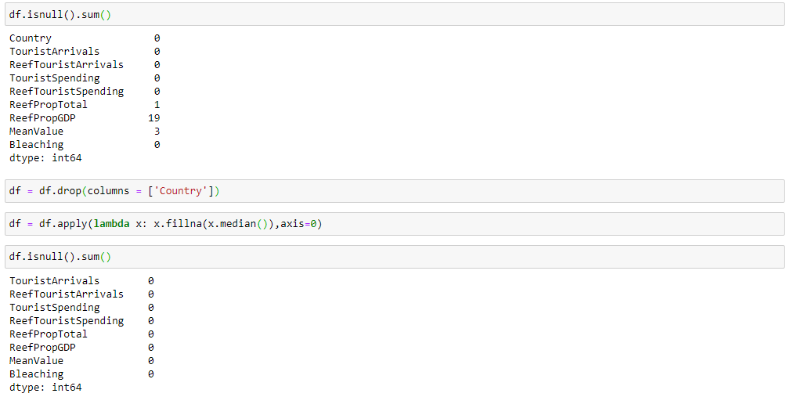
      * The output data is designated to be the boolean data from the column indicating severe bleaching, and the input data is assigned to be the rest of the dataset’s columns, with an exception to the column indicating the country. After the data is split up into the output and input groups, testing and training subsets are created. Next, the data is scaled as to reduce complexity and to avoid any single parameter from being dominant over the other parameters in the calculations.
   3. Artificial Neural Network
      * The prepared data will now be run through a simple artificial neural network (ANN). Once the ANN is initialized and the layers are defined, the ANN will be compiled and fit to the training dataset. After the model is fit, the model is tested with the testing dataset, and the accuracy of the model can be determined using a confusion matrix.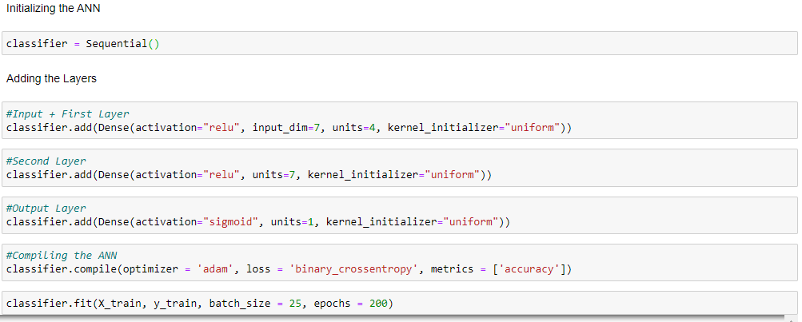
   4. K-Nearest Neighbors
      * The prepared data will now be run through a simple k-nearest neighbors classifier model. The algorithm is run and the accuracy of the model is found using a confusion matrix.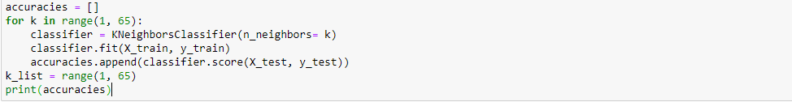
2. Map the different countries with corresponding human impact values (white-red gradient with red showing countries of higher coral bleaching risk).
3. Use t-tests to analyze the significance of the correlation between areas of human activity (e.g. tourism activity, protected areas) and coral reef conditions (e.g. coral bleaching and diseases).
4. Create heatmaps to determine what anthropogenic parameters increase the coral bleaching risk.

*Timeline*

September

* Write proposal
* Collect spreadsheets and data set
* Narrow down the objective based on the available data sets
* Research different methodologies

October-December

* Analyze spreadsheets with different statistical analyses and methods
* Work on data visualization
* Update final copy

January

* Finish the paper

**Results**

*Statistics*

The both of the resulting machine-learning models, ANN and KNN, can predict severe coral bleaching with approximately 69% accuracy. This means that given the correct reef tourism parameters, the model will favor the correct severe bleaching boolean value 69% of the time.

*High-risk Countries (based on maps)*

*Heatmap*

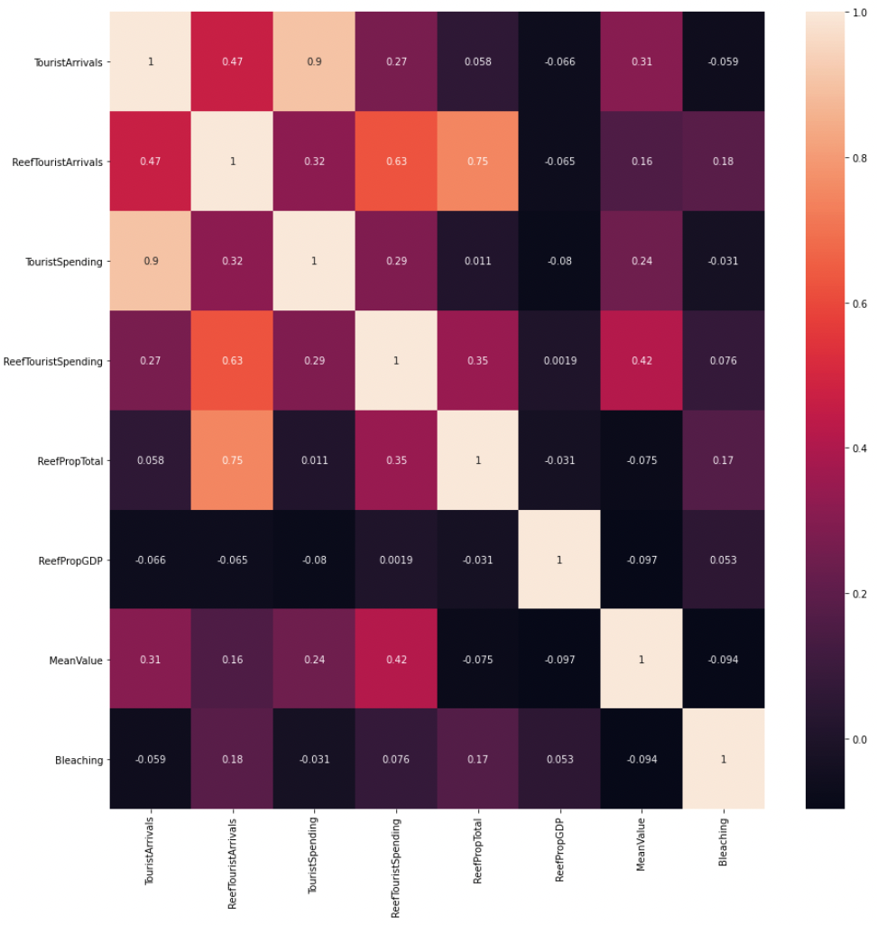

*Figure ?.* Caption

**Discussion**

Correlating specific locations with information regarding anthropogenic impact on coral reefs (e.g. runoff and sedimentation, agricultural pollution, and land development) can indicate priority locations where coral reefs are being degraded as the result of human activity and interaction (Richmond, 1993). Coral reefs that are currently under vast amounts of anthropogenically induced stress can be used as indicators of poor water quality or detrimental human impact (Richmond, 1993). Data obtained while studying the decline of global coral reef populations can be used to set stricter regulations governing anthropogenic activity around bodies of water (Richmond, 1993). The onset of anthropogenic impact on coral reefs imply a cascading and negative outlook — not only for recreational and tourism activities, such as diving and snorkeling, but also worldwide biological diversity (Mansour et al., 2017). Home to 25% of all marine life, coral reefs are in serious decline despite small and large scale efforts to restore them (Hughes et al., 2003). Coral reefs not only provide shelter and a source of food for many aquatic species, but they are also vital to the fishing and pharmaceutical industries (NOAA, 2007). Fishermen rely on coral reefs to provide shelter to desirable sport fish and several pharmaceutical companies have turned to marine corals as a new source of medicine (NOAA, 2007). If action is taken now to protect the globe’s remaining coral reefs, damage not only to the ecosystem, but also to the human way of life, can be mitigated (Richmond, 1993).

**Conclusion**

**References**

Coral bleaching events. (n.d.). Retrieved January 3, 2021, from https://www.aims.gov.au/docs/research/climate-change/coral-bleaching/bleaching-events.html

Dataset: Global Bleaching and Environmental Data. (2019, July 18). Retrieved January 2, 2021, from https://www.bco-dmo.org/dataset/773466

Greenpeace East Asia. (2020, September 24). What is coral? What are the causes, impacts, and solutions of coral bleaching? Retrieved January 01, 2021, from https://www.greenpeace.org/eastasia/blog/6119/what-is-coral-what-are-the-causes-impacts-and-solutions-of-coral-bleaching/

Halpern, B. S., Walbridge, S., &amp; Selkoe, K. A. (2008). A Global Map of Human Impact on Marine Ecosystems. Science, 319(948). doi:10.1126/science.1149345

Hao, K. (2020, April 02). What is machine learning? Retrieved January 06, 2021, from https://www.technologyreview.com/2018/11/17/103781/what-is-machine-learning-we-drew-you -another-flowch art/

Hughes, T. P., Baird, A. H., Bellwood, D. R., Card, M., Connolly, S. R., Folke, C., … Roughgarden, J. (2003). Climate change, human impacts, and the resilience of coral reefs. Science, 301(5635), 929–933. https://doi.org/10.1126/science.1085046

Mansour, S., Awadhi, T. Al, Hatrushi, S. Al, & Buloshi, A. Al. (2017). The Anthropogenic Effects on Coral Reefs Across Northern Coasts of Oman: A GIS based Modeling. Geoinformatics & Geostatistics: An Overview, 05(01). <https://doi.org/10.4172/2327-4581.1000157>

NOAA. (2007, October 12). NOAA's Coral Reef Conservation Program (CRCP) Home Page. Retrieved September 23, 2020, from https://coralreef.noaa.gov/

NOAA. (2013, June 01). Zooxanthellae...What's That - Corals: NOAA's National Ocean Service Education. Retrieved September 23, 2020, from https://oceanservice.noaa.gov/education/tutorial_corals/coral02_zooxanthellae.html

NOAA. (2019, February). Coral reef ecosystems. Retrieved September 23, 2020, from https://www.noaa.gov/education/resource-collections/marine-life/coral-reef-ecosystems

Oceana. (2020). Coral Reef. Retrieved September 23, 2020, from https://oceana.org/marine-life/marine-science-and-ecosystems/coral-reef

Rafferty, J. (2019, February 06). Coral bleaching. Retrieved September 24, 2020, from [https://www.britannica.com/science/coral-bleachin](https://www.britannica.com/science/coral-bleaching)g

Richmond, R. H. (1993). Coral Reefs: Present Problems and Future Concerns Resulting from Anthropogenic Disturbance. *American Zoologist,* *33*(6), 524-536. doi:10.1093/icb/33.6.524

Scott, M., & Lindsey, R. (2018, August 01). Unprecedented 3 years of global coral bleaching, 2014–2017: NOAA Climate.gov. Retrieved September 22, 2020, from https://www.climate.gov/news-features/understanding-climate/unprecedented-3-years-global-coral-bleaching-2014%E2%80%932017

Spalding, M., Burke, L., Wood, S. A., Ashpole, J., Hutchison, J., & Ermgassen, P. Z. (2017). Mapping the global value and distribution of coral reef tourism. Marine Policy, 82, 104-113. doi:10.1016/j.marpol.2017.05.014

Wilson, A. (2019, October 01). A Brief Introduction to Supervised Learning. Retrieved January 3, 2021, from https://towardsdatascience.com/a-brief-introduction-to-supervised-learning-54a3e3932590